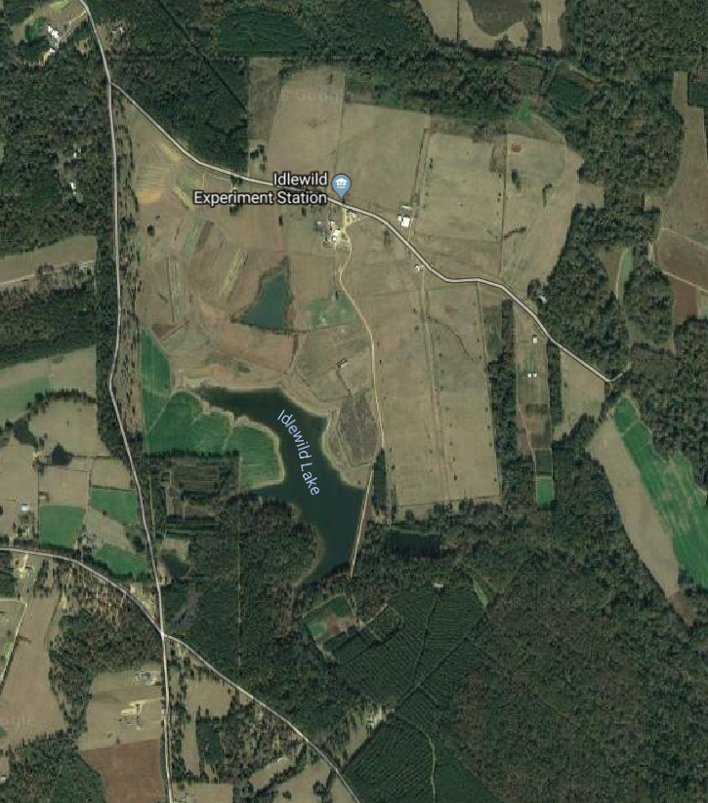
Observatory
Gross Road
N
Feral Swine Workshop
Shooting Sports
Parking
Main Entrance
4419 Idlewild Road
Idlewild Road

